IDEATION PHASE
Empathize & Discover
Date | 31 January 2025
Team ID | 6ab6179bdcoae83adb386708 (Team 6)
Project Name | Auto Ticket Classification using Flow Designer
Maximum Marks | 4 Marks

Empathy Map Canvas
An empathy map is a simple, easy-to-digest visual that captures knowledge about a user’s behaviours and attitudes.
It is a useful tool to help teams better understand their users.
Creating an effective solution requires understanding the true problem and the person who is experiencing it. The exercise of creating the map helps participants consider things from the user’s perspective along with his or her goals and challenges.
Project User: IT Support Ticket User
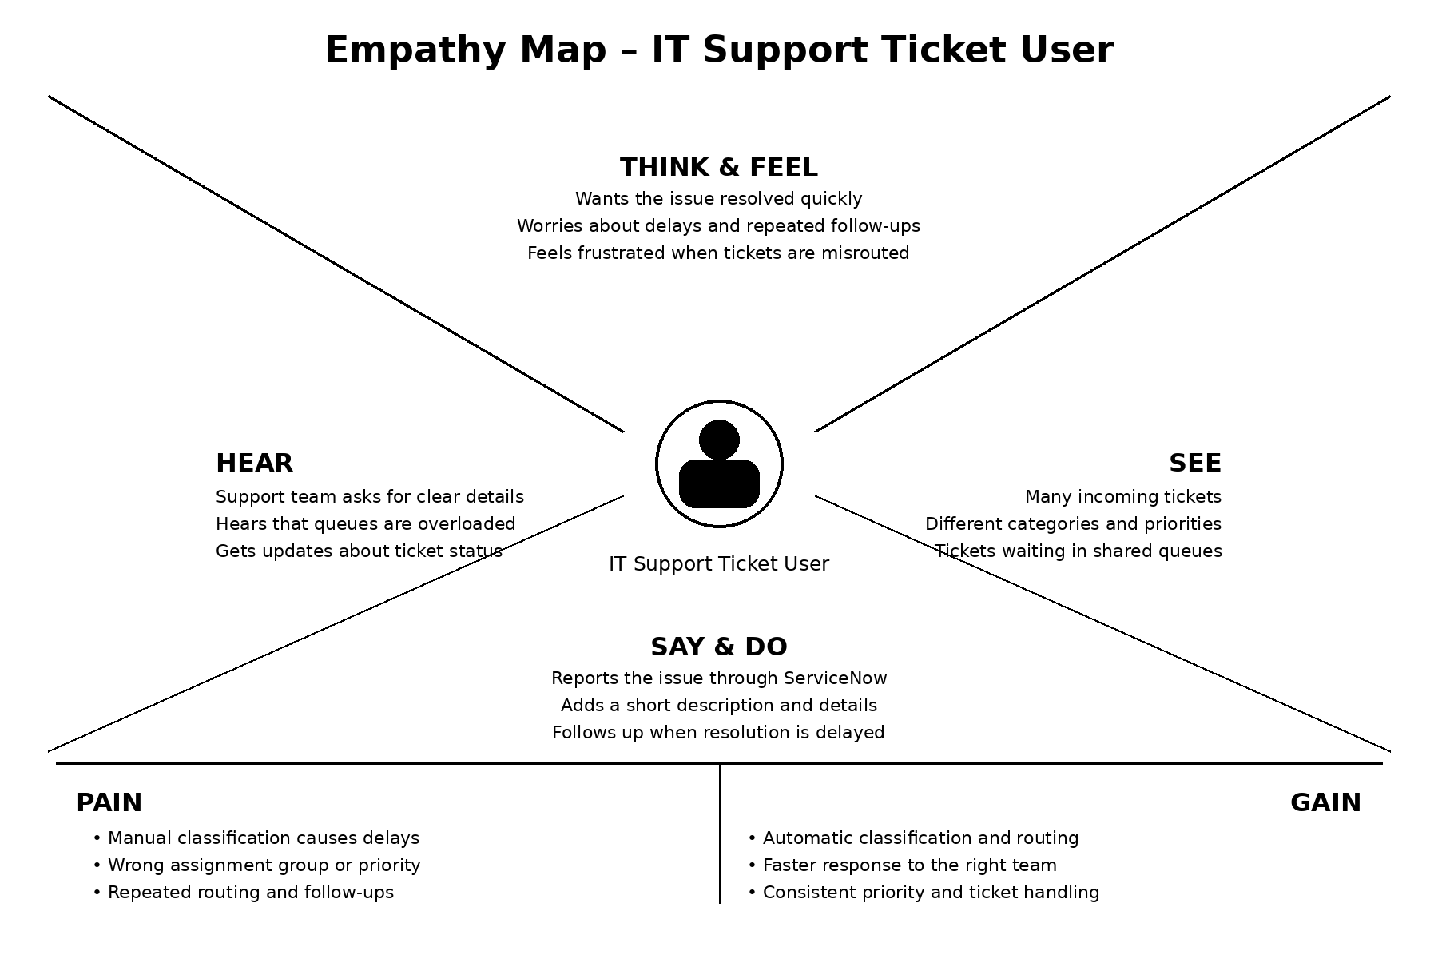
Empathy Map for Auto Ticket Classification using Flow Designer
Reference: https://www.mural.co/templates/empathy-map-canvas

